Once Bitten
Conceived and created by Desmond O’Connor and Zoie Kennedy
Have you ever thought of running away? Joining the circus? Then roll up, roll up! Hear the band’s discordant waltz! See the clowns scream through crocodile tears and the strong-man gorge himself on forbidden flesh, innocently falling in love with an unobtainable ideal, in this twisted circus of humanity. The sequinned lady stands mute as flying knives pin her in place whilst cutting her loose from her desire to please.

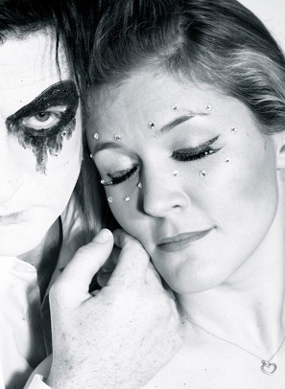
Once Bitten introduces Desmond O’Connor, Zoie Kennedy, Juliette Jeanclaude and a team of gifted musicians, featuring Glasgow’s own ‘Creative Martyrs’ , in a new musical cabaret-theatre piece that explores the desire to lay oneself bare on stage whilst hiding behind the manifold masks of the entertainer. What compels the aerialist to take to the skies for your pleasure? We dare you to join her!
Once Bitten, the show, has also engendered the Once Bitten Creative Community, a free space for artists, audiences and like-minded people to discuss, share and be passionate about issues of identity, acceptance and performance. www.twiceshytheatre.com

Zoie Kennedy is probably best known for her role as Staff Nurse Taylor in ITV's THE ROYAL, but despite screen success her background lies firmly in the theatre. She has toured extensively with some of the greats of British Theatre and is also a director, artist, writer and poet, with work due to be published in New York, 2012. www.zoiekennedy.com
Listings info:
Once Bitten
7:30pm
8th October, 2011
£10
Glasgow Cabaret Festival
Cottiers Theatre
93 Hyndland Street
Glasgow G11 5PX

Box Office: 0141 248 8330

Desmond O’Connor is an internationally renowned and award winning writer, composer, producer and performer. Desmond’s first musical, Failed States, won Best Book and Best Lyrics at the MTM:UK Musical Theatre Awards, 2008 and his ‘Scott Mills: The Musical’ for Radio 1 played to over 6m people. He produces the critically acclaimed Vive le Cabaret (Best Cabaret 2010-Edinburgh Spotlight) and is writer, curator and host on the Terror Season at Soho Theatre this autumn. www.desmondoconnor.com

Juliette Jeanclaude is a painter, performer and founder of www.healingcreativity.com . As well as performing and creating a live projected art piece as part of Once Bitten, Juliette also has an ongoing project in connection with the Once Bitten Creative Community entitled ‘The Clown in You’.

